Experiment -1
NAME: KAVYASRI.V ROLL NO:240701249
Design a UI where users recall visual elements (e.g., icons or text chunks). Evaluate the effect of chunking on user memory.

FRAME 1: HOME / FILTER SCREEN

Chunking, Recall & Recognition (Miller’s Law) Analysis
The Dog-Pedia home screen applies Chunking, Miller’s Law (7 ± 2), and both Recall and Recognition principles to help users understand, remember, and explore dog breed information.

1. Purpose of the Screen
- Acts as the entry point for users to explore dog breeds.
- Helps users form an initial mental model of breed categories, supporting later recall.

2. Key Elements & UI Components
Search Bar
- Allows users to search known breeds.
- Supports recall of breed names while also enabling recognition through suggestions.
Filter Controls
- Energy Level and Maintenance & Grooming sliders.
- Help users recall lifestyle preferences by mapping memory to visible controls.
FIND Button
- Reinforces recall of task flow (filter → find → explore).
Category Cards
- Icons and labels help users recognize categories and remember them for later navigation.

3. Application of Chunking
- Filters and categories are grouped into meaningful chunks.
- Chunking helps users store and recall information as groups instead of isolated details.

4. Application of Miller’s Law
- Total elements remain within 7 ± 2.
- This improves retention and recall accuracy.

5. Recall & Recognition Benefits
- Recognition helps users quickly identify options.
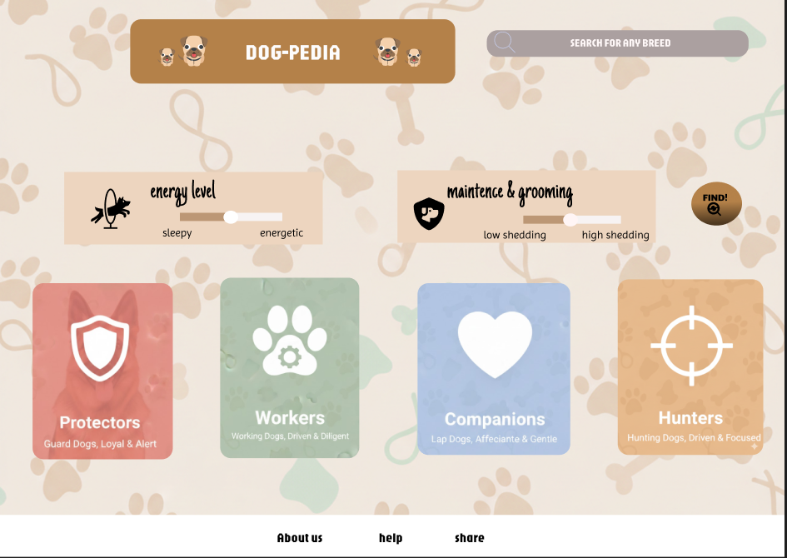
- Recall is supported by repeated exposure to categories, icons, and layout structure.

FRAME 2: PROTECTORS CATEGORY PAGE

Chunking, Recall & Recognition Analysis

1. Purpose of the Screen

Focuses attention on protector breeds.

Reinforces recall of the selected category.

2. Key Elements & UI Components

Category Header

Helps users recall which category they are exploring.

Breed Cards

Image + text combination supports recognition and strengthens memory recall.

3. Application of Chunking

Each breed card acts as a meaningful memory unit.

4. Recall & Recognition Benefits

Users recognize breeds visually.

Repeated exposure supports recall of breed traits and roles.

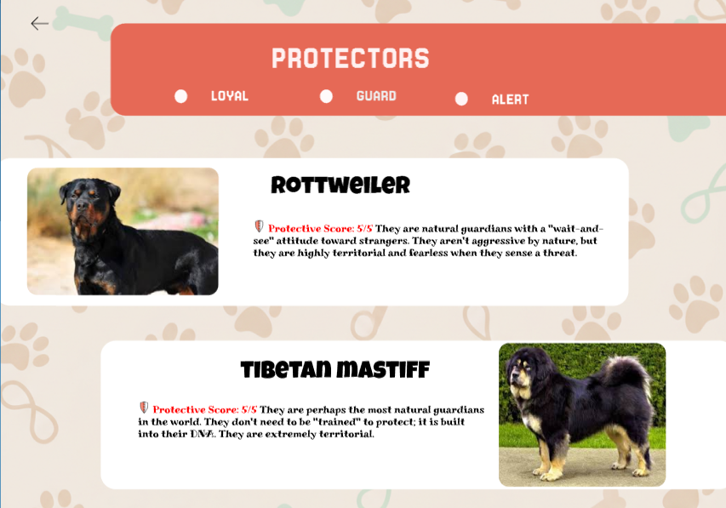

FRAME 3: WORKERS CATEGORY PAGE

Chunking, Recall & Recognition Analysis

1. Purpose of the Screen
- Displays working dog breeds and their behavioral traits.

2. Key Elements
- Consistent layout across category pages.

3. Application of Miller’s Law
- Limited breed cards per screen prevent overload and improve recall.

4. Recall & Recognition Benefits
- Layout consistency supports recognition.
- Familiar structure strengthens recall of navigation patterns.

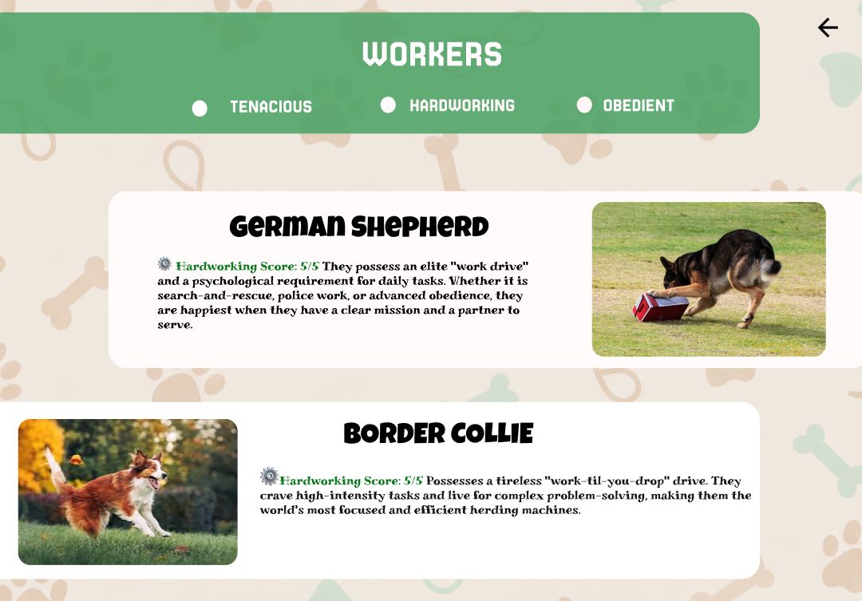

FRAME 4: COMPANIONS CATEGORY PAGE

Chunking, Recall & Recognition Analysis

1. Purpose of the Screen
- Highlights family-friendly breeds.

2. Key Elements
- Emotional traits grouped together.

3. Chunking Strategy
- Trait grouping supports semantic memory and recall.

4. Recall & Recognition Benefits
- Visual cues enable recognition.
- Emotional association enhances long-term recall.

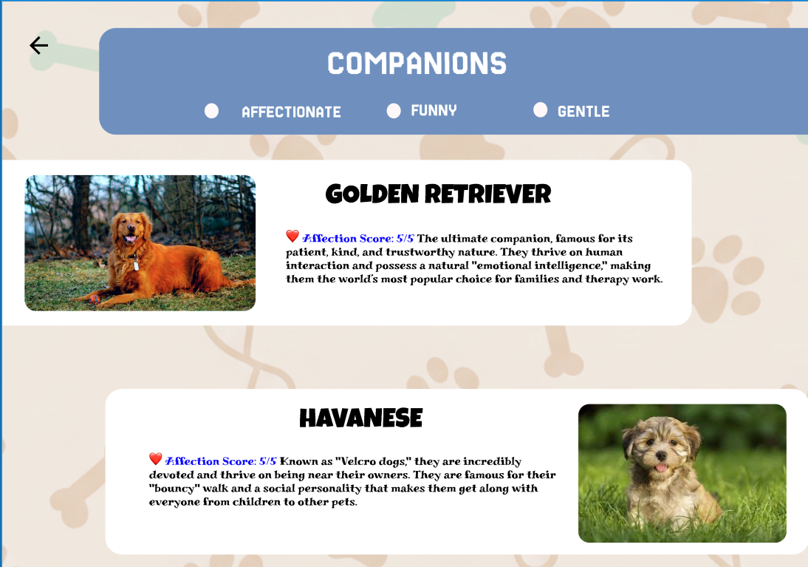

FRAME 5: HUNTERS CATEGORY PAGE

Chunking, Recall & Recognition Analysis

1. Purpose of the Screen
- Displays hunting breeds clearly and sequentially.

2. Key Elements
- Vertical card layout.

3. Application of Chunking
- One card per chunk supports memory encoding.

4. Recall & Recognition Benefits
- Visual repetition strengthens recognition.
- Sequential reading supports recall of breed information.

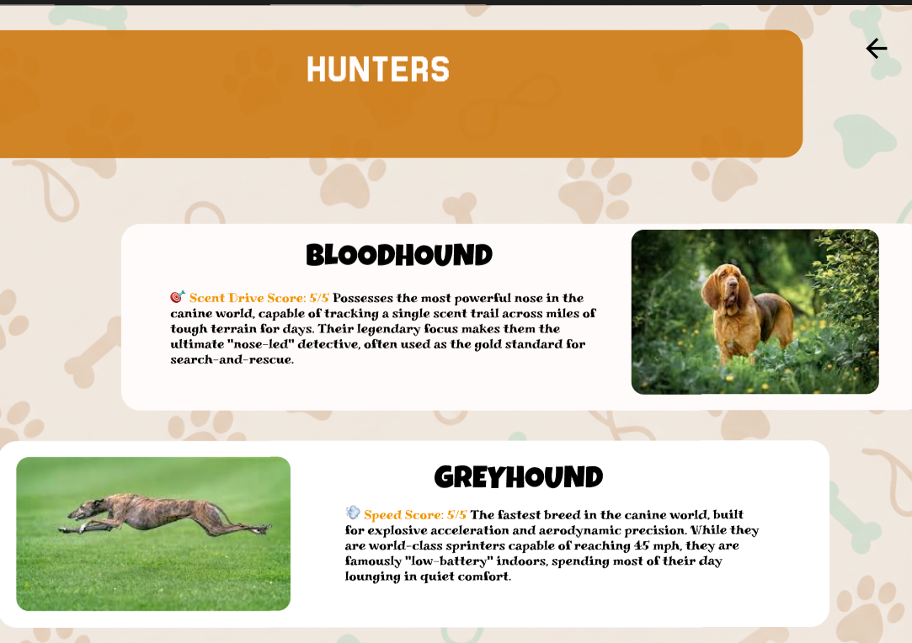

PROTOTYPE LINK:
https://www.figma.com/proto/oq0vKvptrfG2IsEoB0ZhJw/Untitled?node-id=0-1&t=MnQqjPSsQmFRGCvy-1

